**XJTLU Entrepreneur College (Taicang)**

***School of* *AI and Advanced Computing***

**Lab Manual- Lab 1, 2**

***CPT103TC:***

***Introduction to Database***

Shaheen Khatoon

Second Part of Semester 1

**Academic Year 2021-2022**

**Preface**

This laboratory manual serves as supplemental material for the laboratory class. Majority of its contents were taken from the materials of Oracle’s DB Design and Programming with SQL training.

The table below shows the delivery plan with reference material.

|  |  |  |
| --- | --- | --- |
| **Labs** | **Topics** | **Pre-Reading** |
| **1** | Introduction to Oracle Application Express  SQL Workshop for uploading and running scripts | Lab set-up  Oracle Application Development Foundation (Self-study)  SQL Scripts |
| **2** | Demonstrate and end to end application building process | Oracle Application Development Foundation (Self-study) |
| **3** | Data modeling using SQL Developer and ER Assistant | SQL Developer and ER Assistant Tutorial |
| **4** | SQL DDL command to create database objects and constraints | Demo CompanyScript.SQl; |
| **5** | Managing constraints and SQL DML | Lab handouts |
| **6** | Basic SQL | Lab handouts |
| **7** | SQL Group functions and subqueries | Lab handouts |
| **8** | SQL Joins | Lab handouts |
| **9** | SQL Single Row functions | Lab handouts |
| **10** | Application development | Lab handouts |

Table of Contents

**Lab 1: Getting Started with Oracle Application Express** 3

SQL Workshop 7

Loading the Tables and Data 8

Creating a Database Application 13

Creating a Database Application from Scratch 13

**Lab 2: Practice Activities** 20

Managing Pages in Page Designer 20

Developing Reports 20

Application Development skills 21

# **Lab 1: Getting Started with Oracle Application Express**

Log in to Oracle Application Express Workspace. Perform the following steps:

* 1. Open your browser and enter the URL <https://apex.oracle.com/en/> to sign in to Application Express development environment.
  2. The login page appears. Enter the Workspace name, username, and password. Click Sign In. You may be prompted to change your Workspace password the first time you log in.

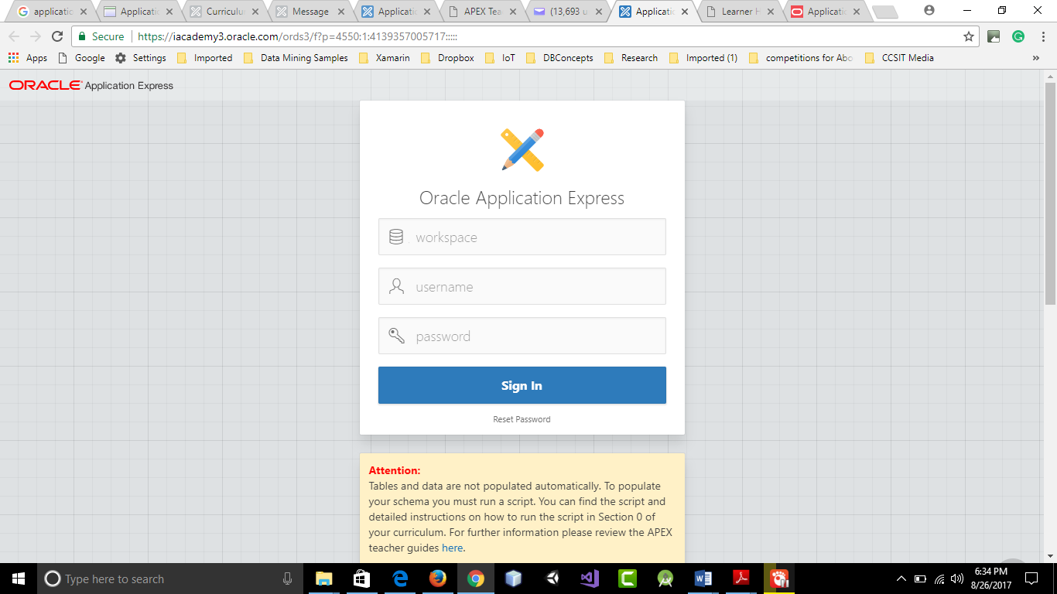

The Application Express (APEX) provide a comprehensive Development IDE, Web Application Development, and SQL Database Development to develop and deploy beautiful, responsive, database-driven web applications using. It is a low-code development platform that enables you to build scalable and secure enterprise apps with world-class features that can be deployed anywhere.

APEX has four components: **Application Builder**, **SQL Workshop**, **Team Development**, and **Gallery**.

In most of the labs, we will be using the SQL Workshop to use SQL statements, However, review each component to get yourself oriented with the features APEX provides.

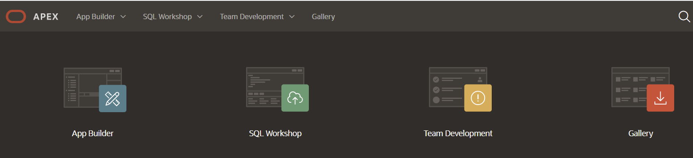

Let us explore each of the components.

**App Builder:**

Integrated Development Environment (IDE) with Application Development Graphical "Page Designer" Features tight SQL and PL/SQL integration.

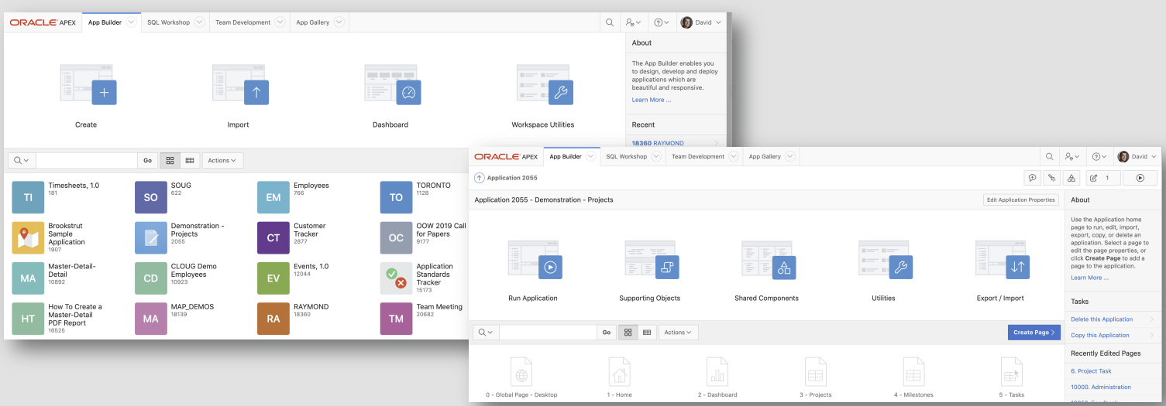

**Team Development:**

Team Development provides a more flexible way to work with colleagues and keep track of tasks, features, bugs and feedback.

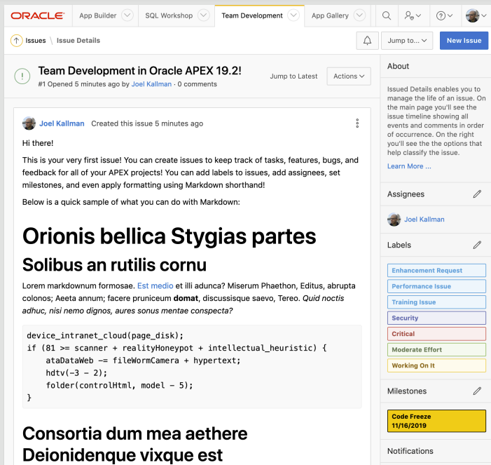

**Gallery:**

App Gallery provides:

Robust suite of productivity and sample applications.

Illustrates best practices and design patterns.

Template to start customization (e.g. unlock your packaged app).

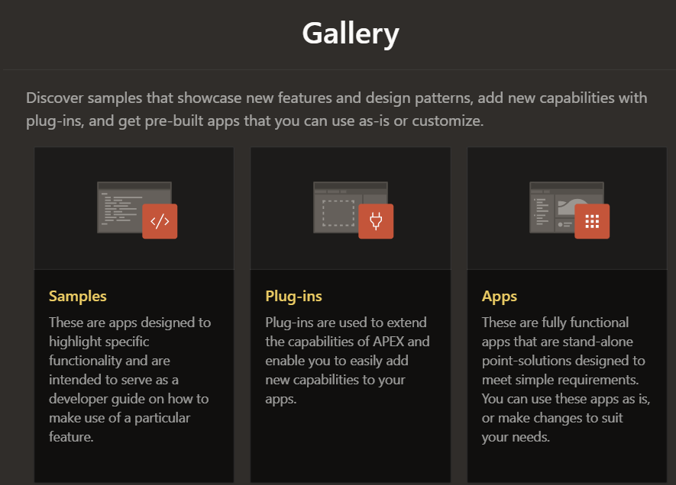

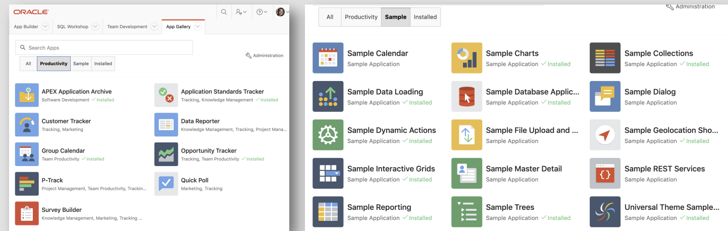

**SQL Workshop:**

SQL Workshop provides tools to view and manage database objects.

Oracle Application Express includes the SQL Workshop for application developers to maintain database objects, from the browser. This feature is particularly important when developing in hosted environments, or where the application developer does not have access to the underlying database, and can not use tools such as SQL Developer or SQL*Plus to manage the database objects.

In the following section, you will be introduced to the SQL Workshop. You will learn how to interact with the database by using the different components of the SQL Workshop.

## SQL Workshop

**NOTE:** To run hands-on **labs extract apex-course-labs** (came along with lab manual) to your working directory. The script is required for hands-on lab for covering application development topics**.**

From the Application Express home page, you can access SQL Workshop in either of the following two ways:

* Click the SQL Workshop icon and then select the component you want to access

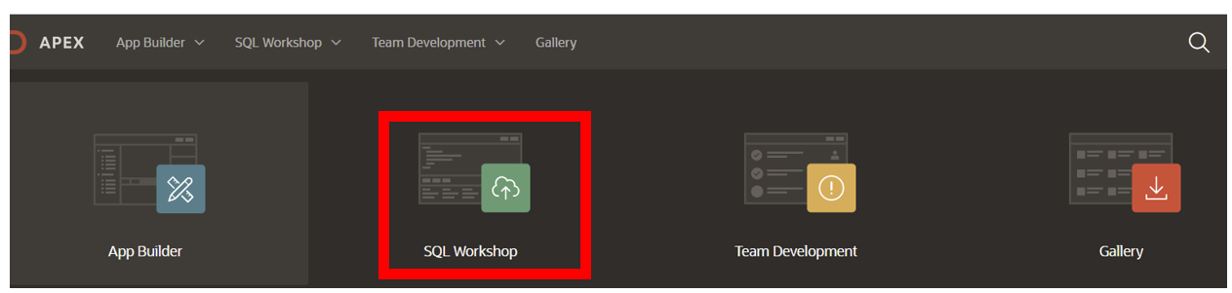

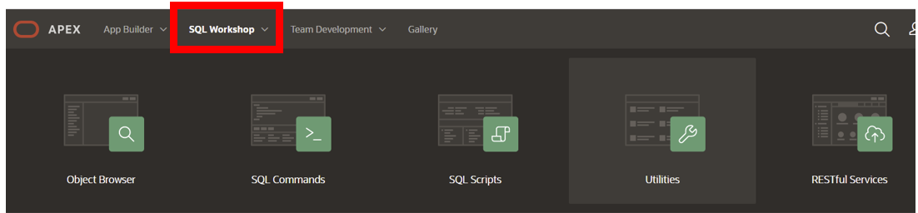

* Or click the down arrow on the SQL Workshop tab. Then, select the component you want to access

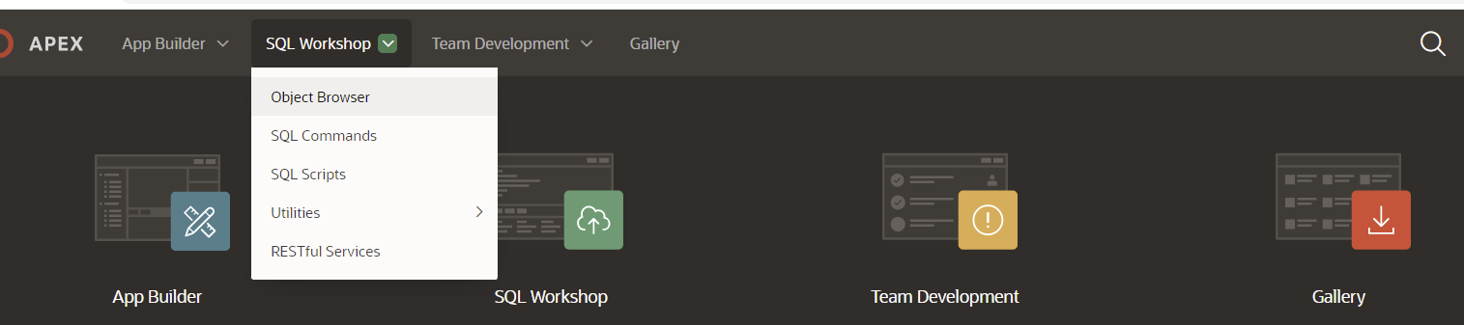

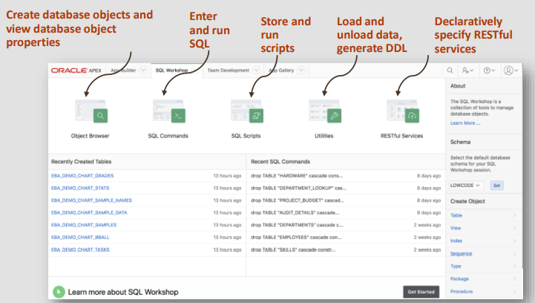

* The SQL Workshop provides tools that enable you to view and manage database objects. Based on the task, you use the following component of SQL Workshop:
  + **Object Browser**: This component enables developers to browse, create, and edit objects in a database
  + **SQL Commands:** You use SQL Commands to create, edit, view, run, and delete database objects. A SQL command can contain SQL statements or PL/SQL blocks.
  + **SQL Scripts:** A SQL script is a set of SQL commands saved as a file in SQL Scripts. A SQL script can contain one or more SQL statements or PL/SQL blocks. You use SQL Scripts to create, edit, view, run, and delete database objects.
  + **Utilities:** You use Oracle Application Express utilities to build SQL queries, load and unload data from an Oracle database, generate DDL, view object reports, manage User Interface Defaults, restore dropped database objects, compare schemas, monitor the database, and view database details
  + **Restful Services:** RESTful Services enable the declarative specification of RESTful services used to access the database. These services work with the Oracle REST Data Services (formerly known as Oracle Application Express Listener) to enable the consumption of these services. This component helps you to create, edit and delete RESTful Services. If the instance administrator has disabled RESTful Services for this Application Express instance, RESTful Services are not available for this instance and the RESTful Services icon does not display.

We will be using SQL commands and SQL scripts in this course to cover Structured Query Language (SQL).

## Loading the Tables and Data

It is essential to have at least the tables defined in order for the Create Application wizard to generate pages in your application. In this activity, you create the required database objects and populate the tables with sample data.

1. Use SQL Workshop to upload a script that creates the tables for the Demo Projects application. Perform the following steps:
   1. Navigate to SQL Workshop and select SQL Scripts

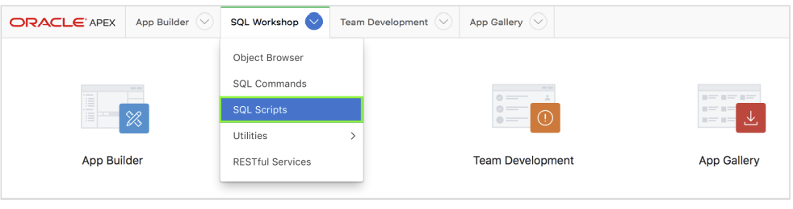

* 1. Click Upload

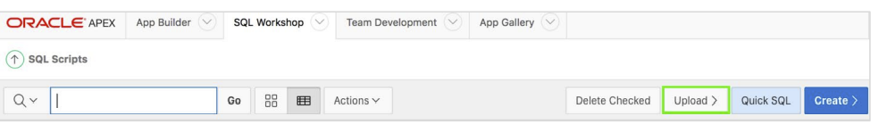

* 1. Click Choose File

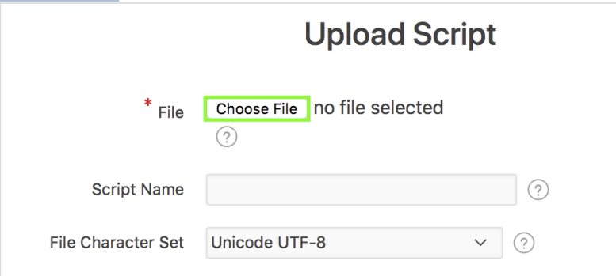

* 1. Navigate to the working directory where you extracted apex-course-labs.zip. Locate the Project_Tables.sql file, and double-click the file or click the file and then click Open. Click Upload.

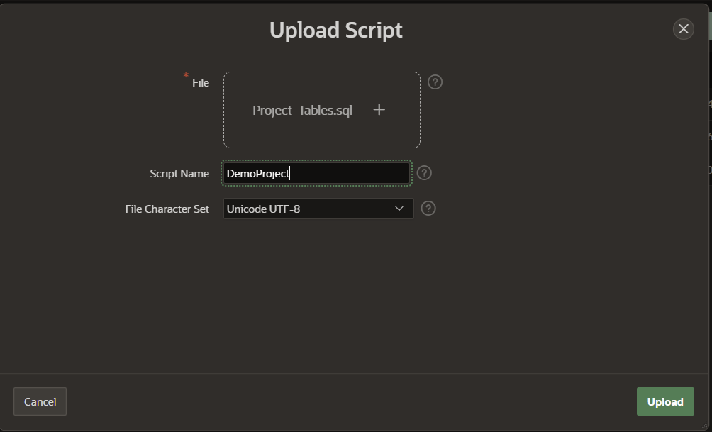

* 1. Review the uploaded script to see what tables will be created. In the SQL Scripts list, click the Edit icon (pencil), to the left of the script you just uploaded.



* 1. Click the Run icon to the right of the script you uploaded.

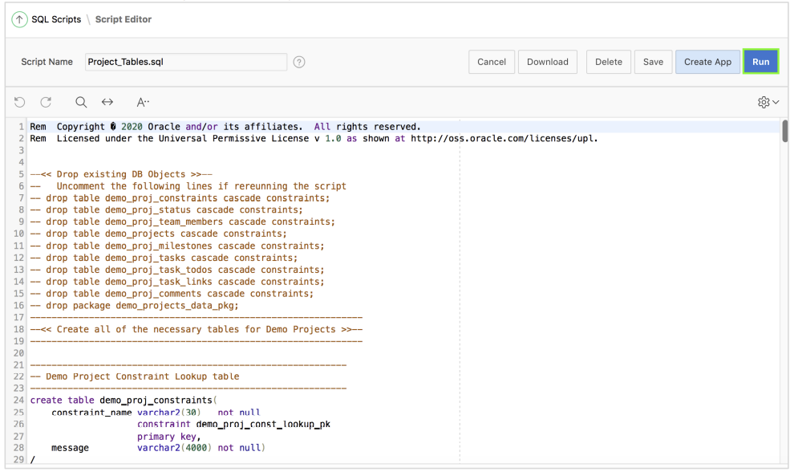

* 1. Then, click Run Now

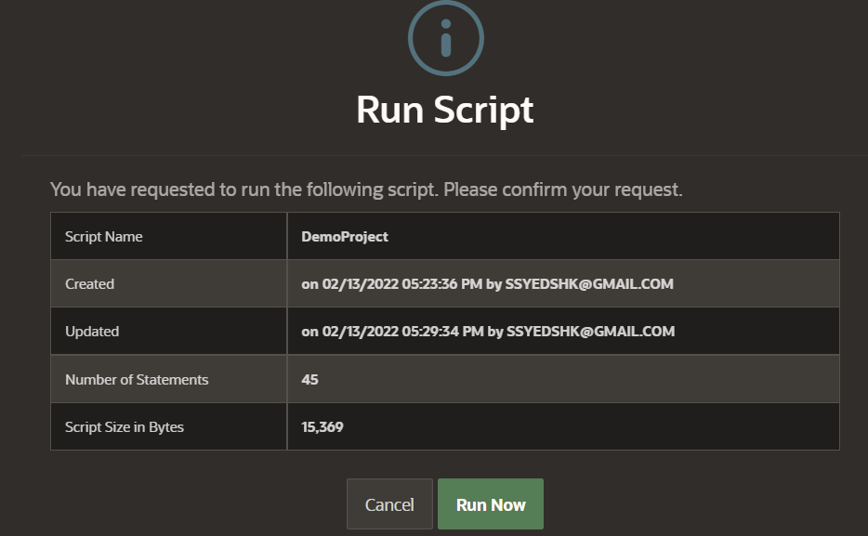

* 1. Scroll down to view the results of the script that you just ran.

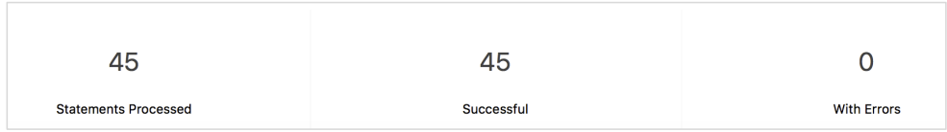

1. Currently the tables you created do not have any data. A script has been provided that creates an Oracle database package that can be run at any time to insert or reset the data in the tables. Use SQL Workshop to upload a script that you can use to populate table data. Perform the following steps:
   1. Click SQL Scripts. Click Upload

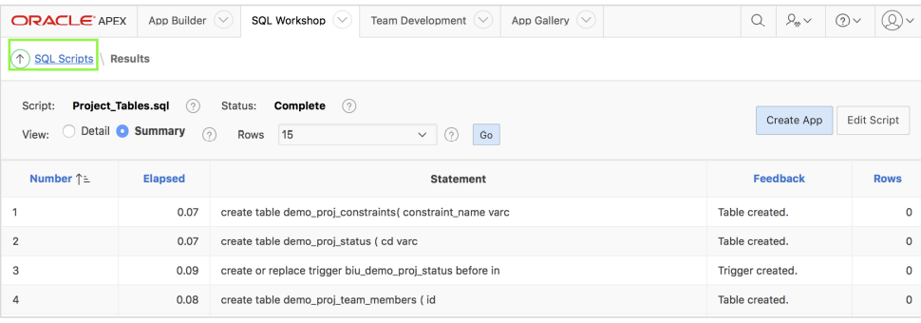

* 1. Click Choose File, where you extracted apex-course-labs.zip.
  2. Locate the **Project_Data.sql** file, and double-click the file or click the file and then click Open. Click Upload.
  3. Click the Run icon to the right of the script you uploaded (top row).

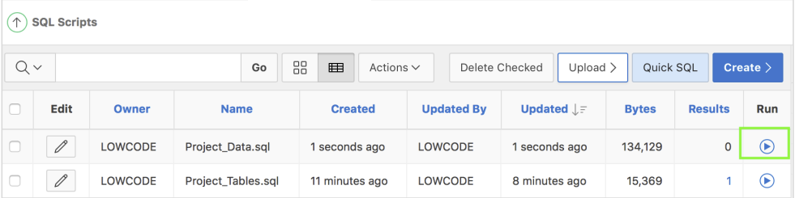

* 1. Then, click Run Now.
  2. Scroll down, to view the results for the script you just ran.

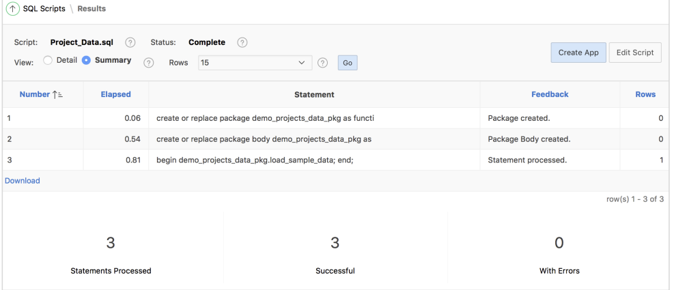

* 1. Go to object browser under SQL workshop and view what database objects have been created. Select tables and view what tables are created, view tables

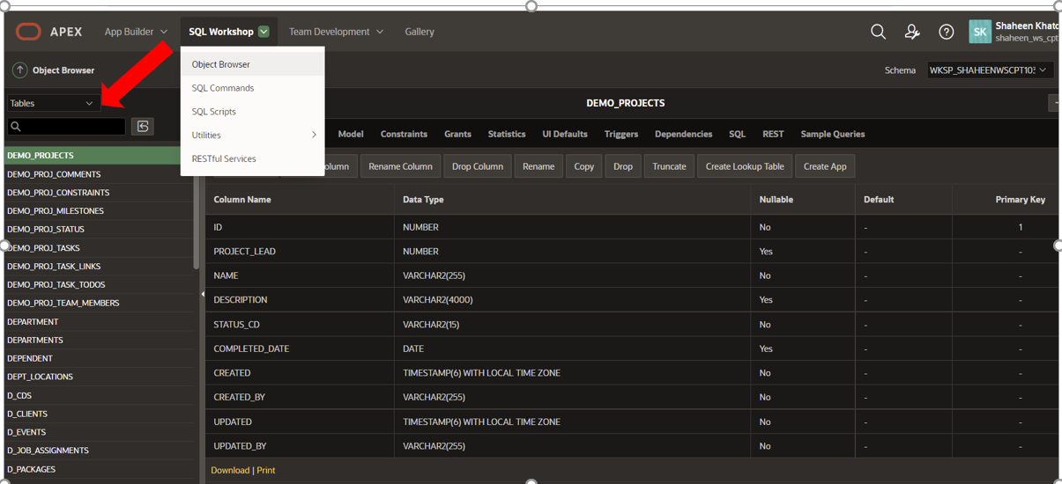

Click on each tab (Table, Data, Model, etc., ) to get familiar with database objects. If you don’t understand anything, don’t worry, Slowly you will get familiar with these items.

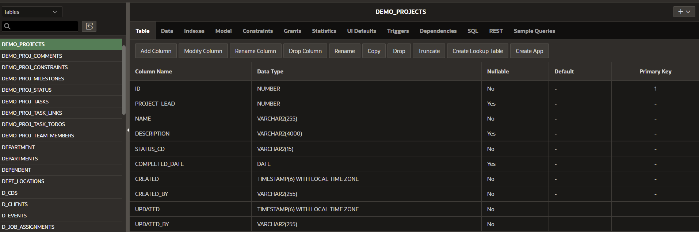

# Creating a Database Application

An application is an HTML interface that exists on top of database objects such as tables or procedures. You use App Builder to build the pages that make up an Oracle Application Express application.

In this activity, you create the initial application using the Create Application wizard to define multiple pages. Now that you have created the underlying tables, you are ready to create a desktop application. You will be adding reports and forms for the tables you created. Generally, when developing an application you will not know all of the pages required at the beginning. Therefore, you will only generate a select number of pages initially, and then use the wizard to add additional pages as required. However, for this activity you will generate most of the pages required for the application up front.

The Create Application Wizard enables developers to design and quickly create basic Oracle Application Express applications. By using the Create Application Wizard, you can create a complete application containing multiple pages including a variety of different reports and forms. After you create an application using this wizard, you can modify pages and also add additional pages. You can use the Create Application Wizard to create an application with just a blank page or a complete application containing multiple pages.

## Creating a Database Application from Scratch

Using the Create Application Wizard, create the Demo Projects application. Navigate to App Builder and then click Create

On your workspace home page, click App Builder. Then, perform the following steps:

1. Click Create.

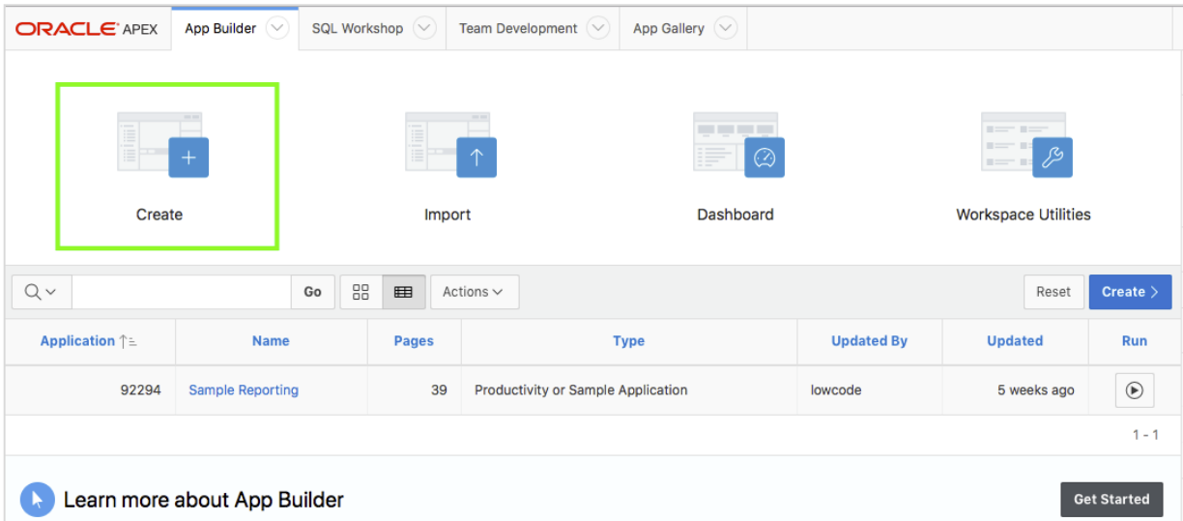

1. You want to create a new application. Click New Application.

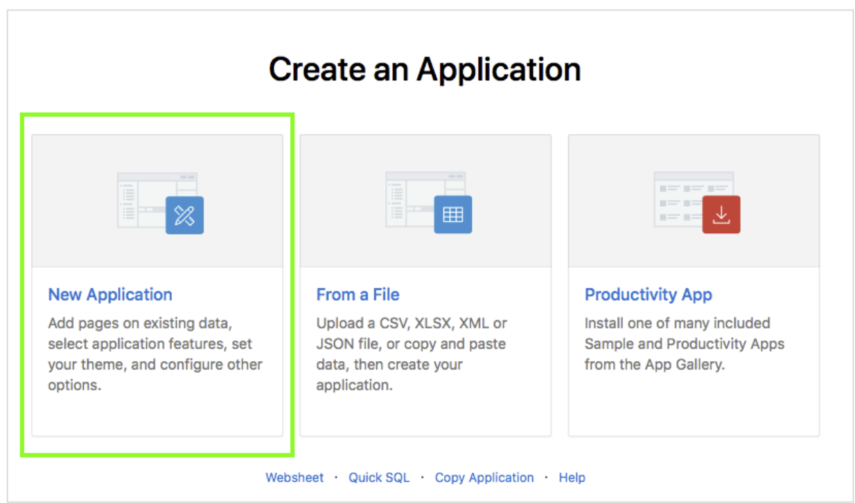

1. The Create an Application page appears.
2. For Name, enter Demo Projects. For Appearance, click the Set Appearance icon.

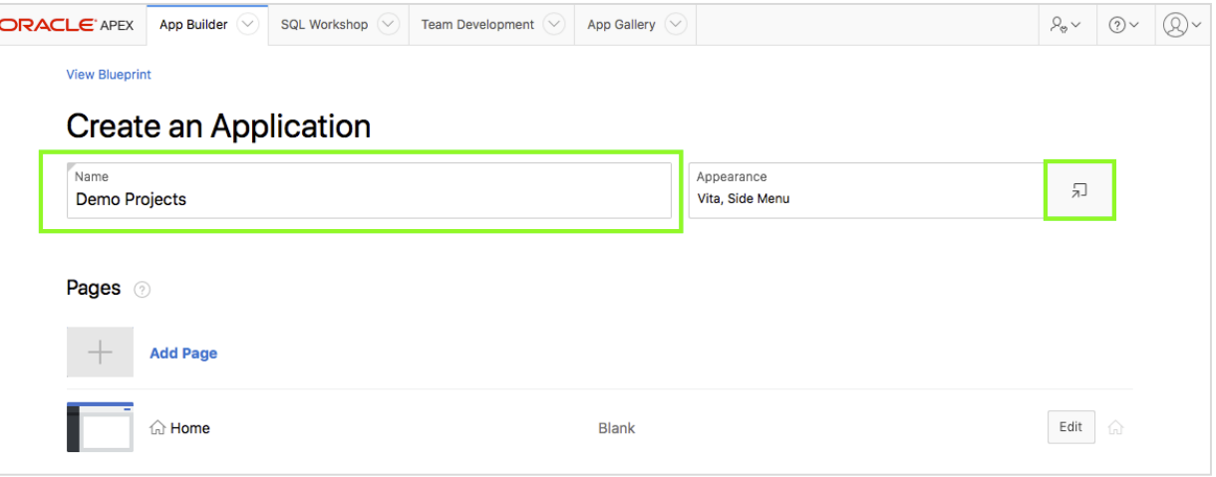

1. For Appearance, you can accept the default (Vita, Side Menu). If you want to change the appearance, click the Set Appearance icon adjacent to the Appearance field. In the slide example, click the Set Appearance icon and save.

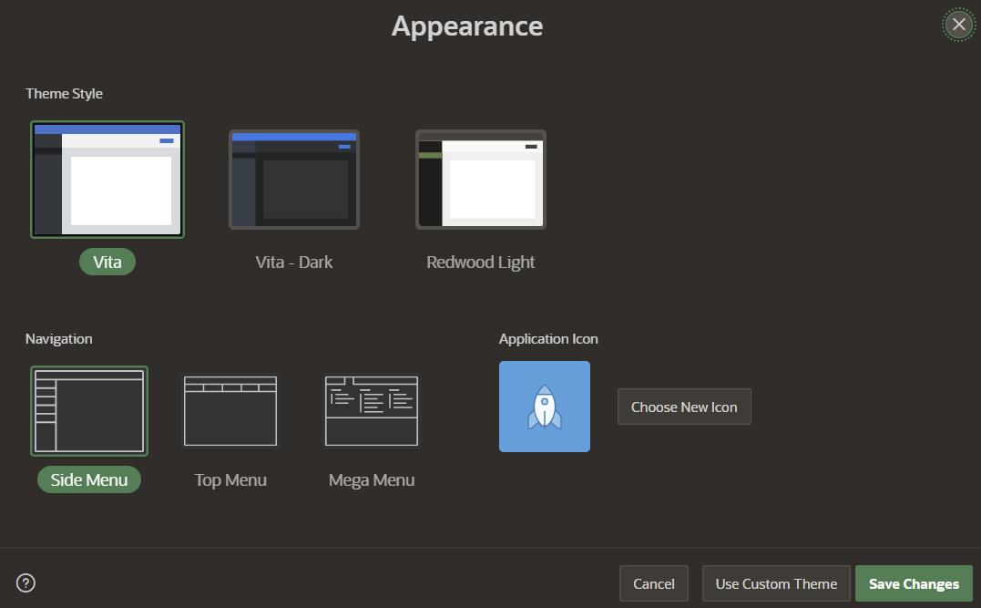

1. Now, you add pages to your application. Click Add Page.

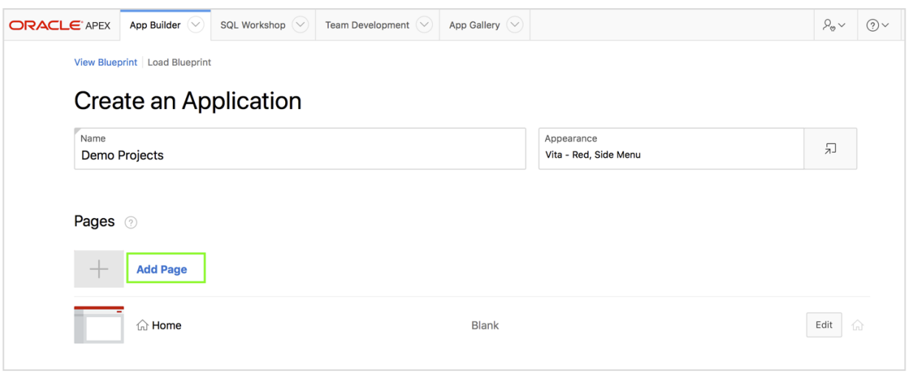

1. The Add Page dialog appears. Select the desired page type. The user interface changes based on the selected page type. Pages you create display under the Home page. After you create an application using the Create Application Wizard, you can modify pages and add additional pages using the Create Page Wizard.
2. Next, add Report and Form page types for the following tables: DEMO_PROJ_TEAM_MEMBERS

DEMO_PROJECTS

DEMO_PROJ_MILESTONES

DEMO_PROJ_TASKS

1. In the Add Page dialog, click **Interactive Report**.
2. In the Add Report Page dialog, perform the following steps:

* For Page Name, enter DEMO_PROJ_TEAM_MEMBERS.
* For Table or View, select DEMO_PROJ_TEAM_MEMBERS.
* Select the Include Form checkbox and click Add Page.

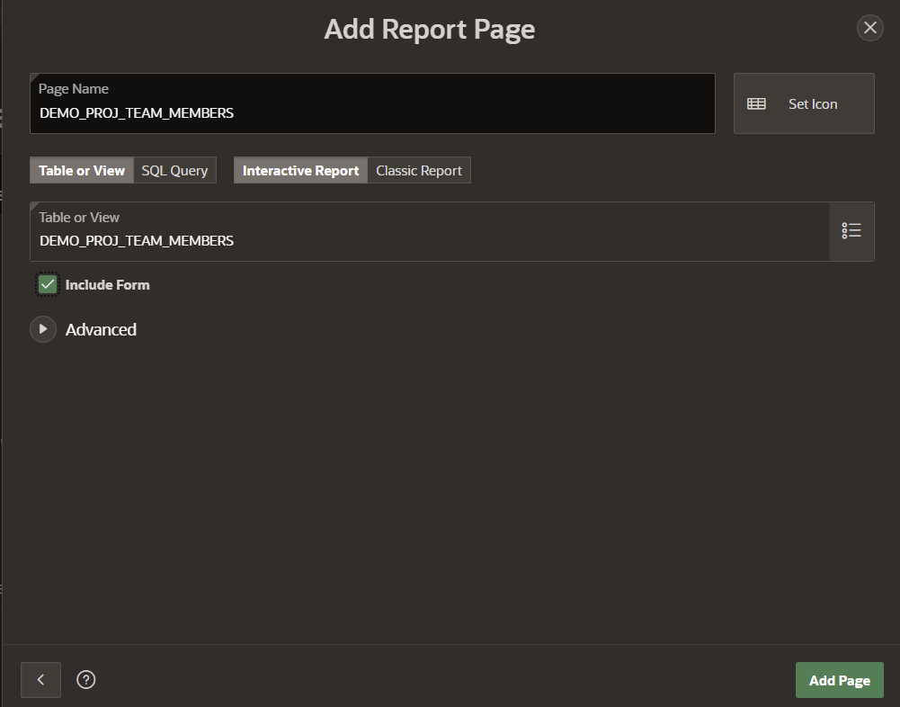

1. Add Report and Form page type for the DEMO_PROJECTS table.

* Click Add Page.
* In the Add Page dialog, click Report

1. In the Add Report Page dialog, perform the following steps:

* For Page Name, enter DEMO_PROJECTS.
* For Table or View, select DEMO_PROJECTS.
* Select the Include Form checkbox and click Add Page.

1. Add Report and Form page type for the DEMO_PROJ_MILESTONES table.

* Click Add Page
* In the Add Page dialog, click Report

1. In the Add Report Page dialog, perform the following steps:

* For Page Name, enter DEMO_PROJ_MILESTONES.
* For Table or View, select DEMO_PROJ_MILESTONES.
* Select the Include Form checkbox and click Add Page.

1. Add Report and Form page type for the DEMO_PROJ_TASKS table.

* Click Add Page.
* In the Add Page dialog, click Report.

1. In the Add Report Page dialog, perform the following steps:

* For Page Name, enter DEMO_PROJ_TASKS.
* For Table or View, select DEMO_PROJ_TASKS.
* Select the Include Form checkbox and click Add Page.

1. Click Check All next to Features.

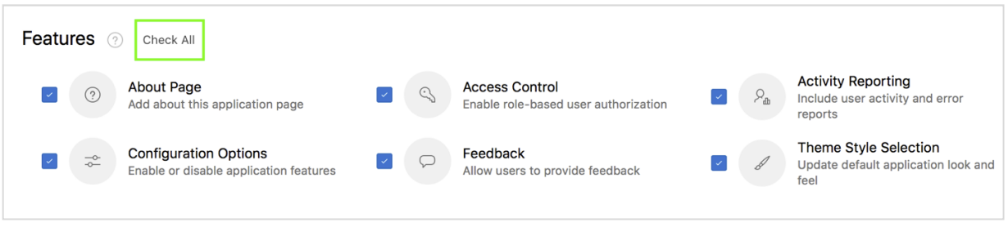

1. Under Settings, select Advanced Settings.
2. Enter the following advanced settings:

* Short Description - enter **Maintain project details**.
* Description - enter **This application is used to maintain project details for the team. Projects include milestones, where you can define due dates. Tasks can be defined against a milestone or directly against the project.**
* Under Settings, for Add "Built with APEX" to Footer, turn ON.

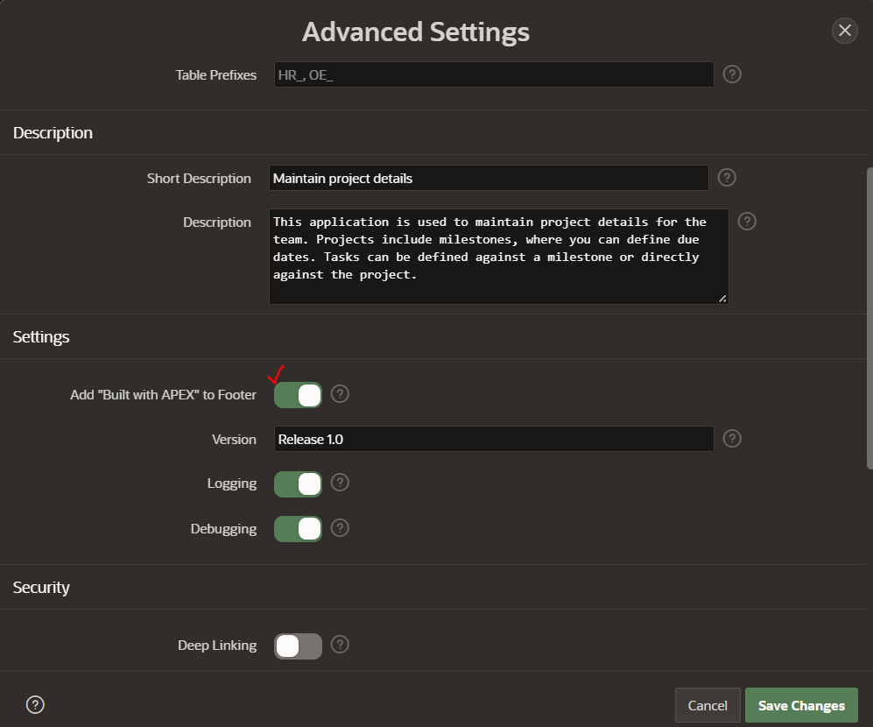

1. Click Create Application. Notice the application creation progress.
2. The Demo Projects application is now created. Click Run Application.

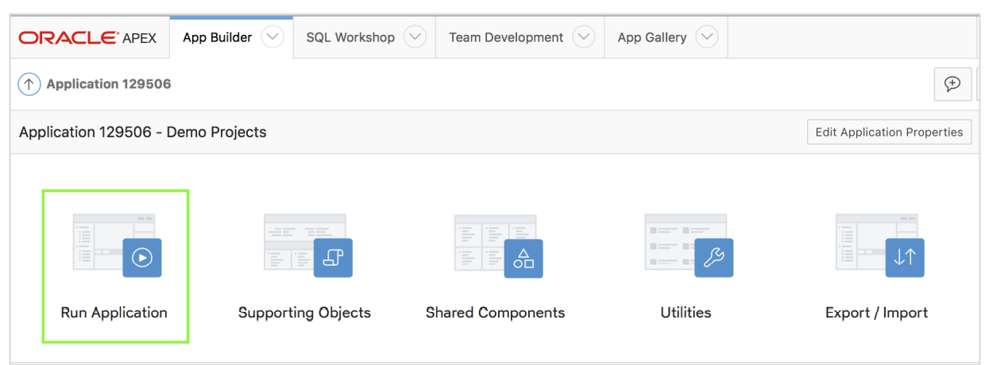

1. Log in using your Workspace username and password.

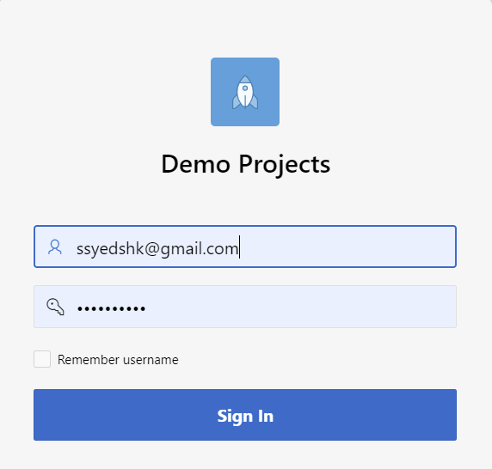

1. Your screen should look like the following:

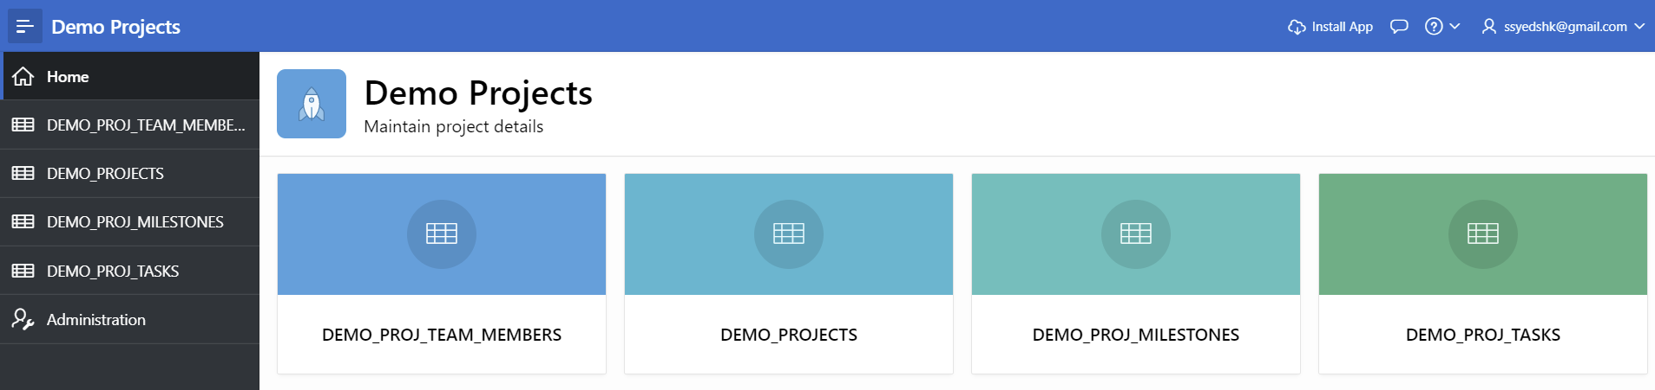

1. Click any report and you will notice that each report has CREATE button which allows you to open a form to insert records in the given table. This is a very easy way to add more record through this form, instead of using DML commands, which you will learn later.

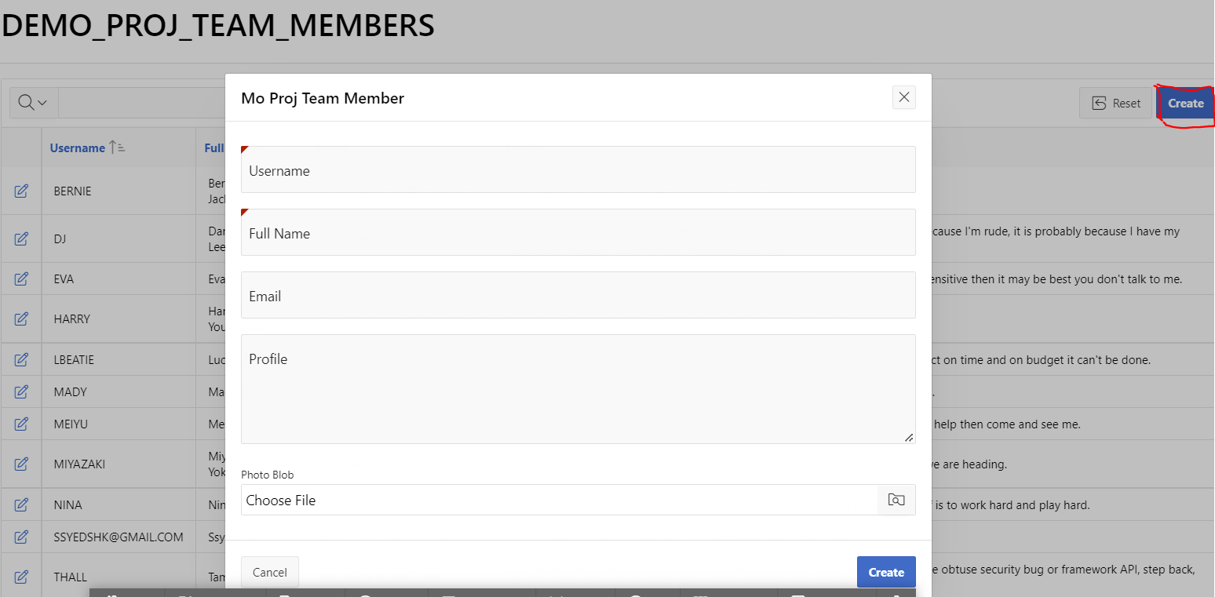

# **Lab 2: Practice Activities**

**Note**: Application development (App Builder) is not in the scope of our course. You have given a simplified demo for the end-to-end application development so that you can create a beautiful application for your course project.

A full course on application development is provided in the resource section at LMO under **Application Development Foundation**. It is highly recommended to go through the material to learn detail about application development. The app development is all wizard-based and not much programming involved. Therefore, it is highly recommended to self-study the material to develop a reasonable application for your projects.

Please go through the below-given topics from **Application Development** Foundation material to practice the following Activities:

## Managing Pages in Page Designer

Reading: ADFo_3_1_Practice

In this activity, you create a dashboard by adding a new component to the Home page of the Demo Projects application. You open the home page in page designer, navigate through and review the page designer panes, add a chart region and edit the chart attributes.

## Developing Reports

This practice includes three activities.

1. Creating a Classic Report: In this activity, you create a classic report region on the Dashboard page of the Demo Projects application. Reading (Essential reading: ADFo_3_2_**Practice Activity-1**)
2. Creating an Interactive Report: In this activity, first, you create a new database application from a Spreadsheet (follow steps from ADFo_2_2_ **Practice Activity-2:)** and then using the Create Page wizard, you add an interactive report page (follow steps for creating a report from **ADFo _3_2 Practice Activity-2:**
3. Creating an Interactive Report. Creating an Interactive Grid: In this activity, you use the Create Page wizard and add an interactive grid page in the Budget App application. **Reding: ADFo _3_2 Practice Activity-3**

# Application Development skills

So for you have learned basic application development, however, APEX offers enormous features to develop large-scale database applications. It is highly recommended to practice at least the following topic from Application Development Foundation, self-study material, to apply these features in your course project.

* 3-3: Managing and Customizing Interactive Reports
* 3-4: Managing and Customizing Interactive Grids
* 4-1: Creating and Using Forms
* 4-2: Creating Application Page Controls
* 4-3: Adding Computations, Processes, and Validations
* 5-1: Implementing Navigation in your Application
* 5-2: Using Themes and Theme Styles